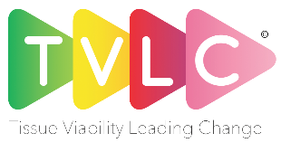
TVLC Business Skills Development Module - 2022
Project outline guide for sponsorship application
(max 500 words)

Name of Applicant
& Project Title
Project Sponsor | Do you have a project sponsor? This will be someone (maybe your line manager) who will help with the project stages and remove potential barriers.
Background | Where did the project idea or improvement come from?  Describe any background detail to provide context.
Project Scope | Provide an overview of the change project
Objectives | List the project objectives
Deliverables | List of tasks to be completed or actioned
Timescales | List of what you feel needs to be done, with approximate timescales
Potential barriers | Any difficulties or problems you feel may arise with your project
Stakeholders | Everyone who will be involved in the project in some way – those who you may need to consult with.

Please email your application by 31st December 2021 to
Sarah Summerson, Head of Learning and Development, Urgo Medical
s.summerson@uk.urgo.com

